**Courier Management system**

**USER GUIDE**

|  |  |  |  |  |
| --- | --- | --- | --- | --- |
| **S.NO** | **Students Names** | **Enrollment Number** | **Group** | **Batch Code** |
| **STD.1** | **Osama** | **Student1314680** | **A** | **SBTE-202103-F** |
| **STD.2** | **Anas** | **Student1313624** | **A** | **SBTE-202103-F** |
| **STD.3** | **Abdullah** | **Student1313639** | **A** | **SBTE-202103-F** |
| **STD.4** | **Tayyab** | **Student1314711** | **A** | **SBTE-202103-F** |
| **STD.5** | **Shabbir** | **Student1314643** | **A** | **SBTE-202103-F** |

**HOME NAVBAR:**



**LOGIN FORM:**

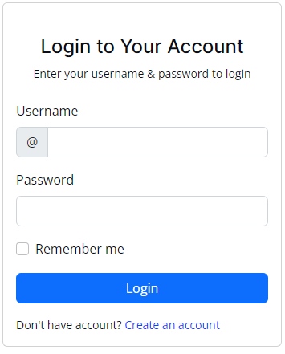

**REGISTERATION FORM:**

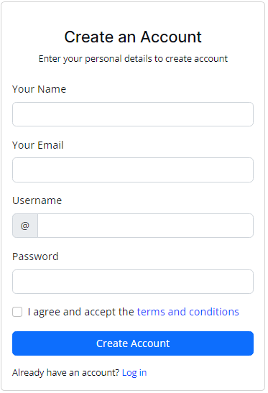

**HOME :**



**SERVICES HOME:**



**ABOUT US:**



**CONTACT US:**



**CONTACT US FORM:**

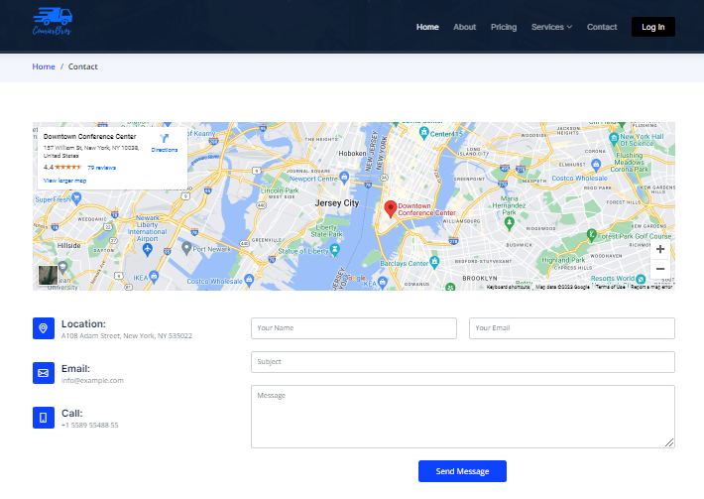**SERVICES:**

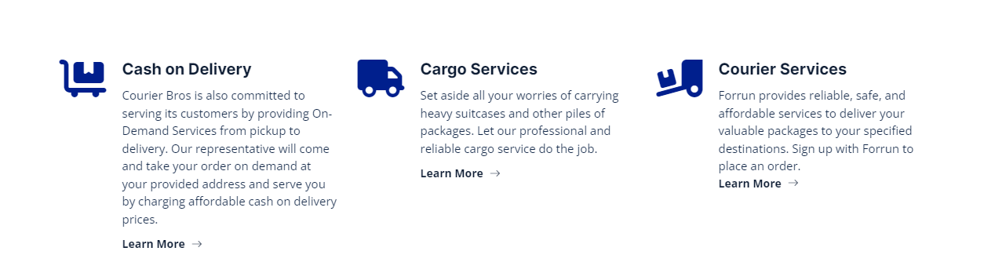

**ABOUT US:**

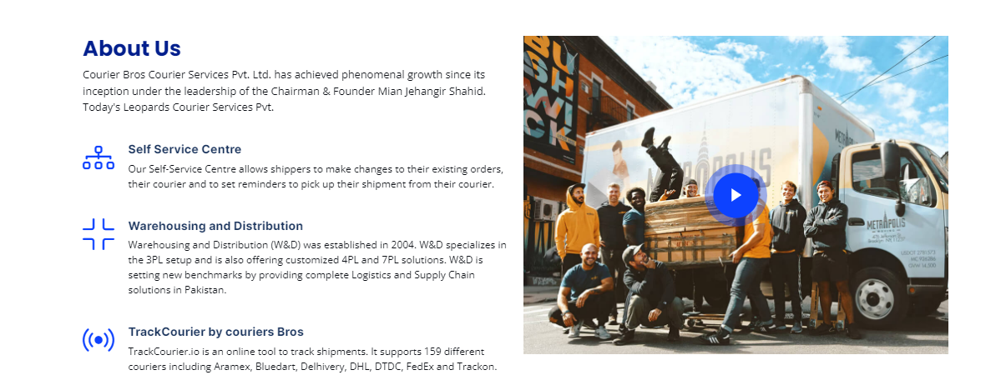

**CONTACT HOME:**



**CUSTOMER FEEDBACK:**

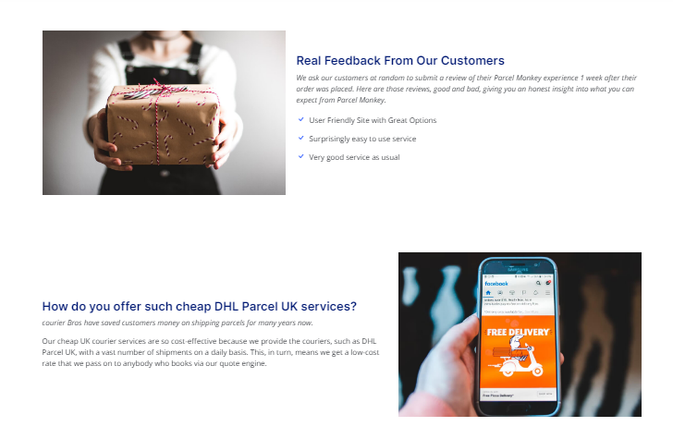

**MEMBERSHP PLANS PRICING:**

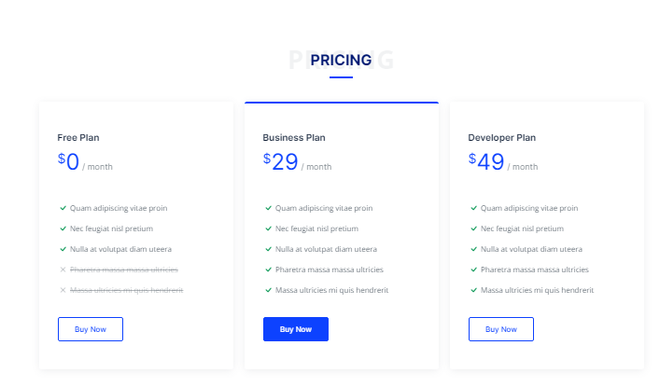

**Testimonials, Blogs:**



**FREQUENTLY ASKED QUESETIONS:**

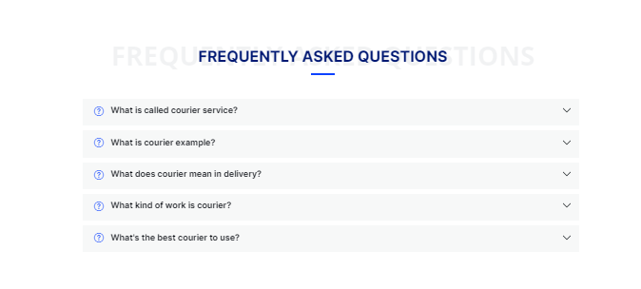

**FOOTER:**



**DASHBOARD:**

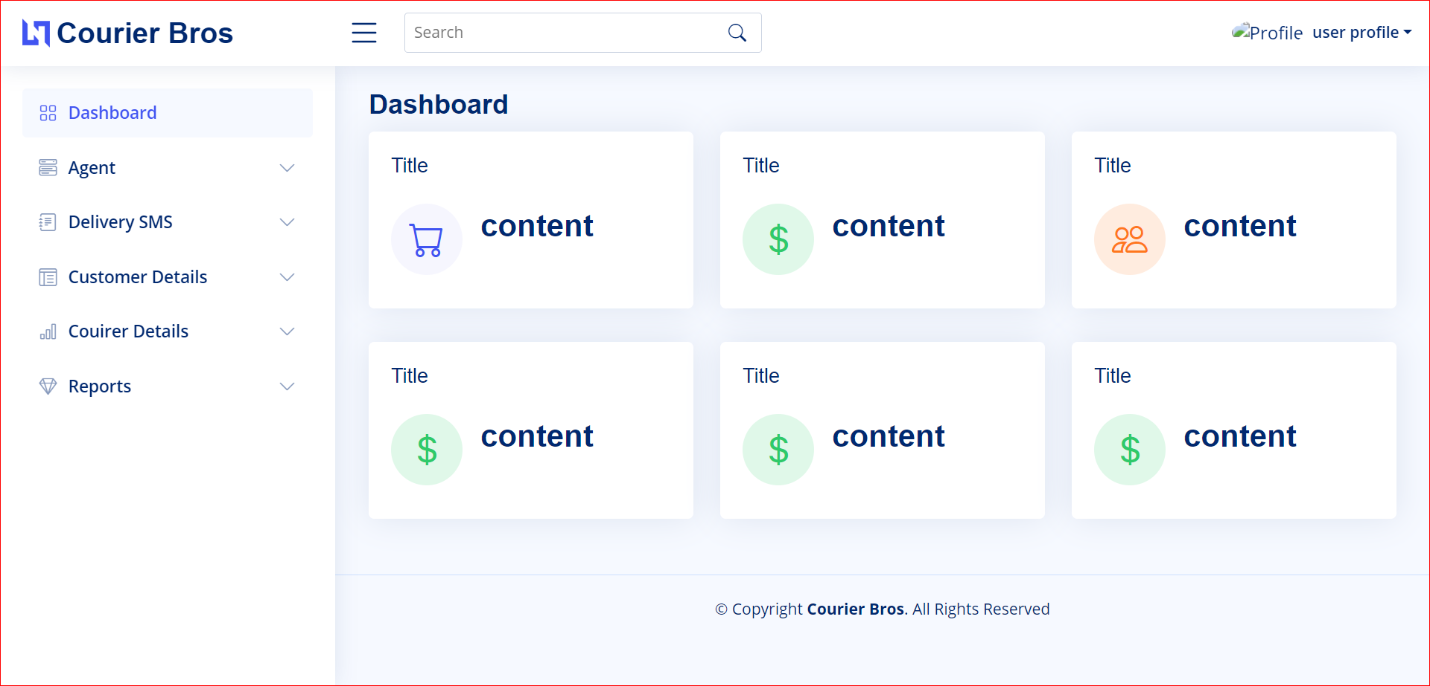

**DELIVERING SMS:**

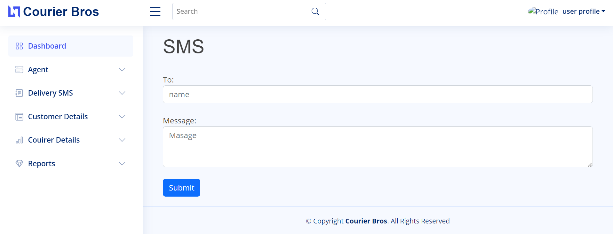

**COURIER DETAILS:**

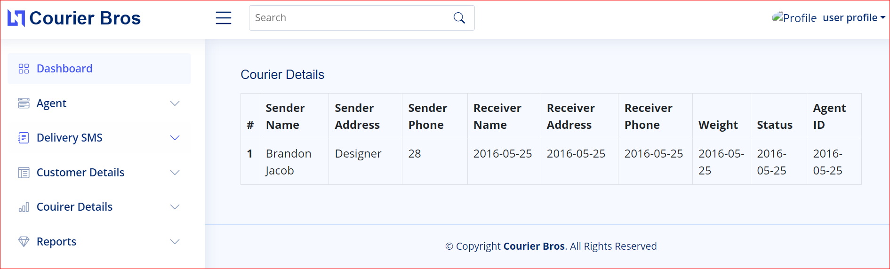

**CREATE AGENT:**

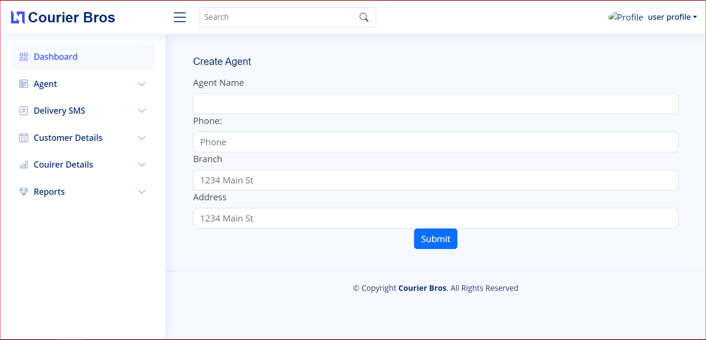

**DATATABLES:**

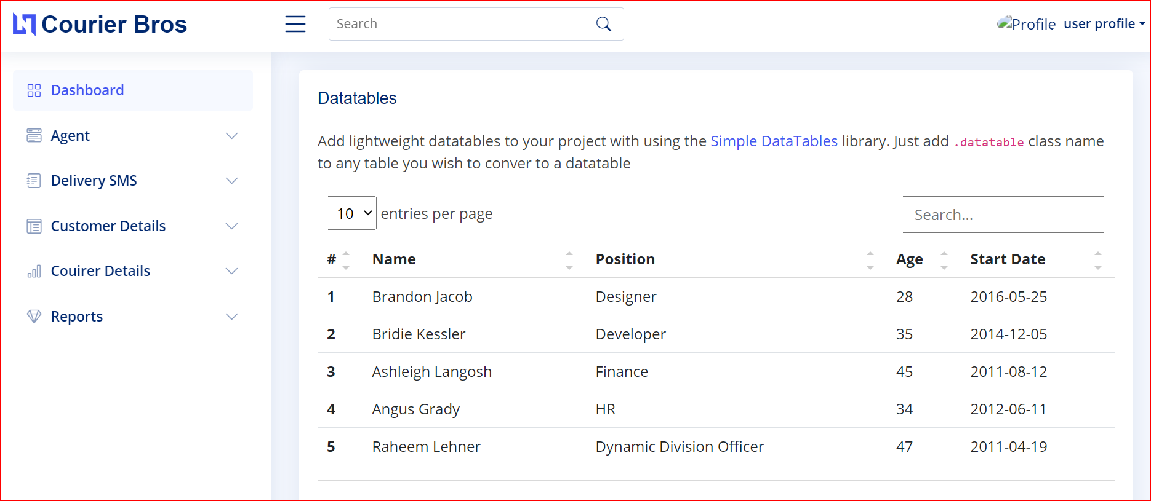

**AGENT DETAILS:**

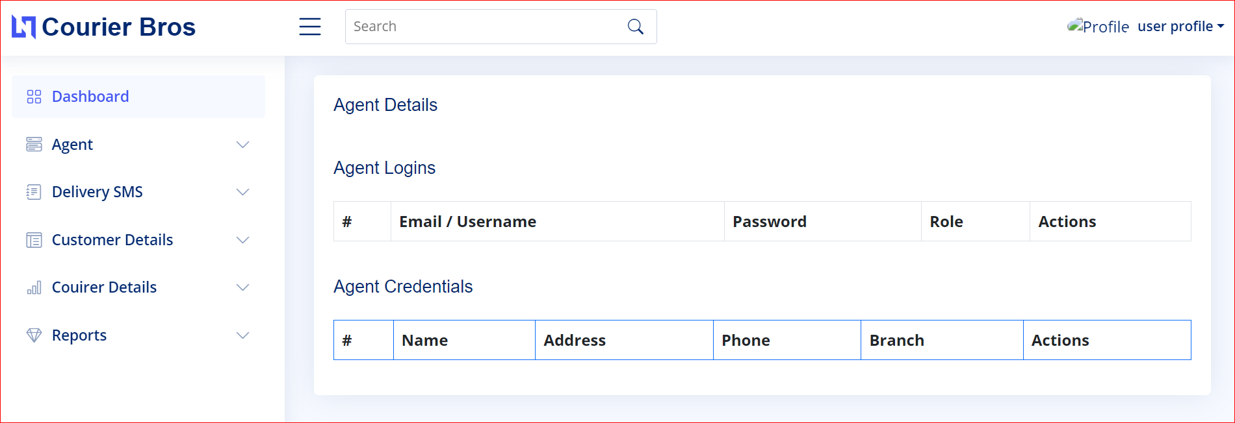

**FLOATING TABLES FORM:**

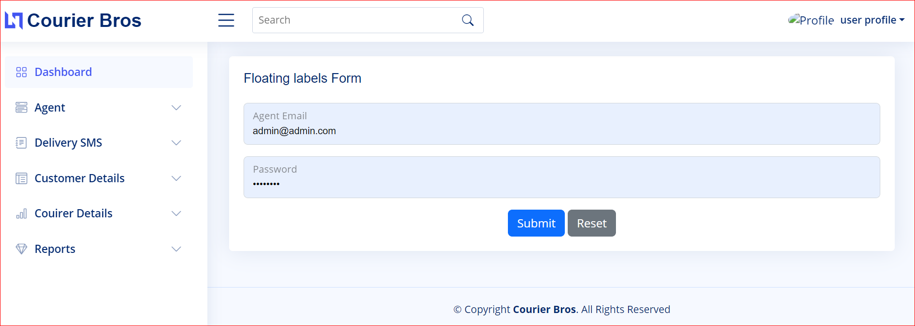

**STRIPPTED ROWS:**

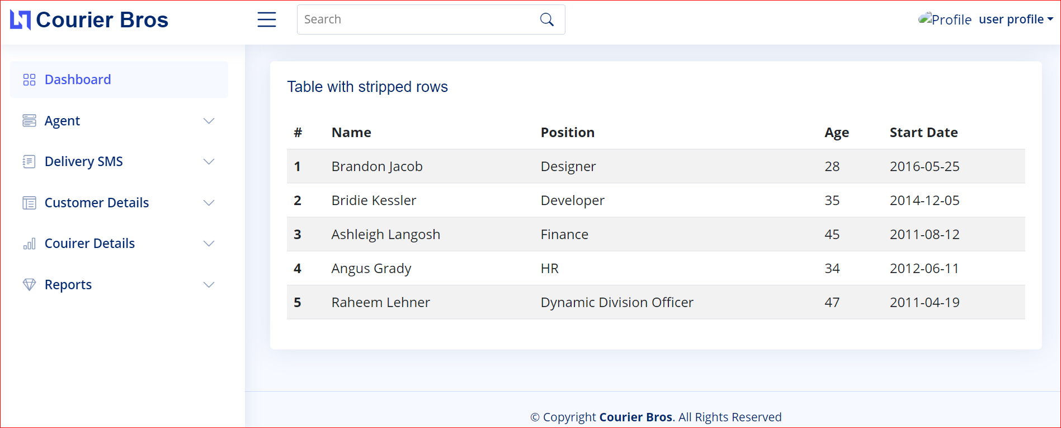

**Thank You for Reading the Documentation. Please Follow the Instructions Above!!**